Let’s GO Raiders! Work out like a Professional:)
# RaiderStrong
Phys Ed Week 5

- Activity 1- Warm Up – 10 Exercises, 30 Seconds each = 5 minutes
Sidestep + Arm Pull Downs, Butt Kickers (slow), High knee Pull Ups, Arm Swing with a Sidestep, Torso Twist + Knee Up, Jog in Place, Squats, Front Kicks, Boxer Shuffle, Cross Toe Touches
Click on the link below for demonstration and proper technique
https://www.youtube.com/watch?v=R0mMyV5OtcM
Activity 2+3 Alternate Daily
- Activity 2 “AMRAP (As Many Reps as Possible) Complete as Many Reps as Possible”
“Complete the 10 exercises in the circuit below. Complete each exercise for 20 Seconds then REST for 10 seconds and move on to the next exercise in the circuit. Each time you complete all 10 exercises it is called a set. Complete as many sets as you can in each time frame. Start slow, maybe 10 minutes then buildup 10 15min.

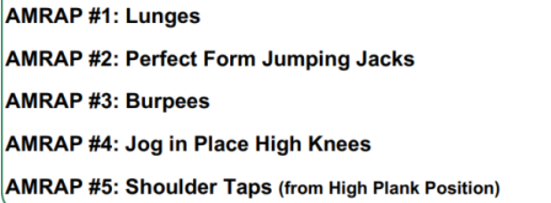
Here are some important things to keep in mind:
- Form is more important than
speed.
- Rest when needed
- Keep exercise simple
- Record your results- challenge
yourself

Activity 3 “Me Time Workout”
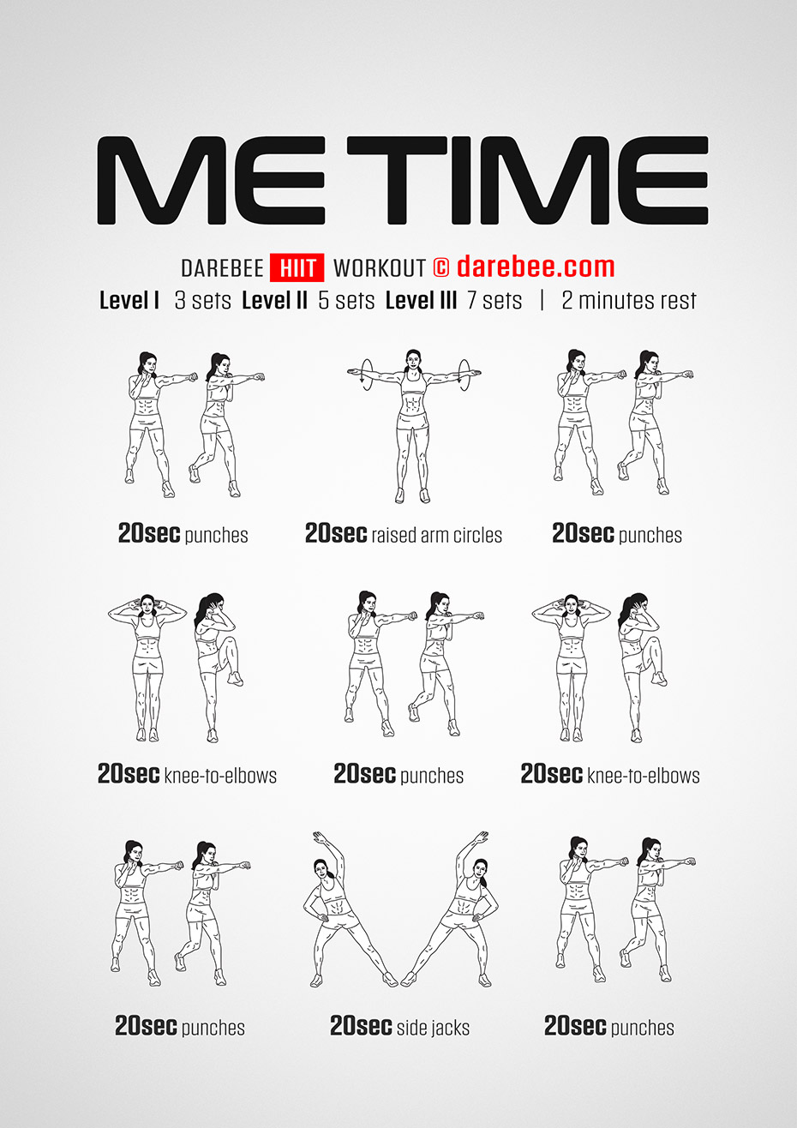
Challenge yourself, start at level 1 (3 sets) and work your way up to level 111 (7 sets)

